State Management

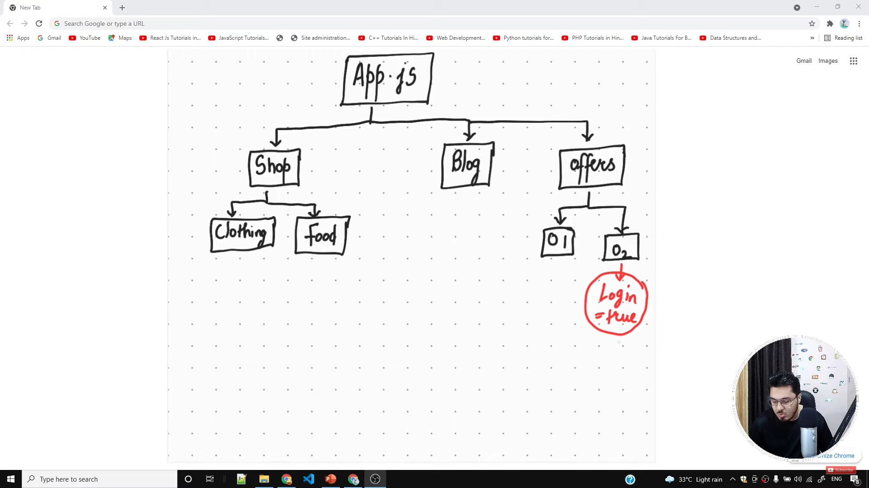

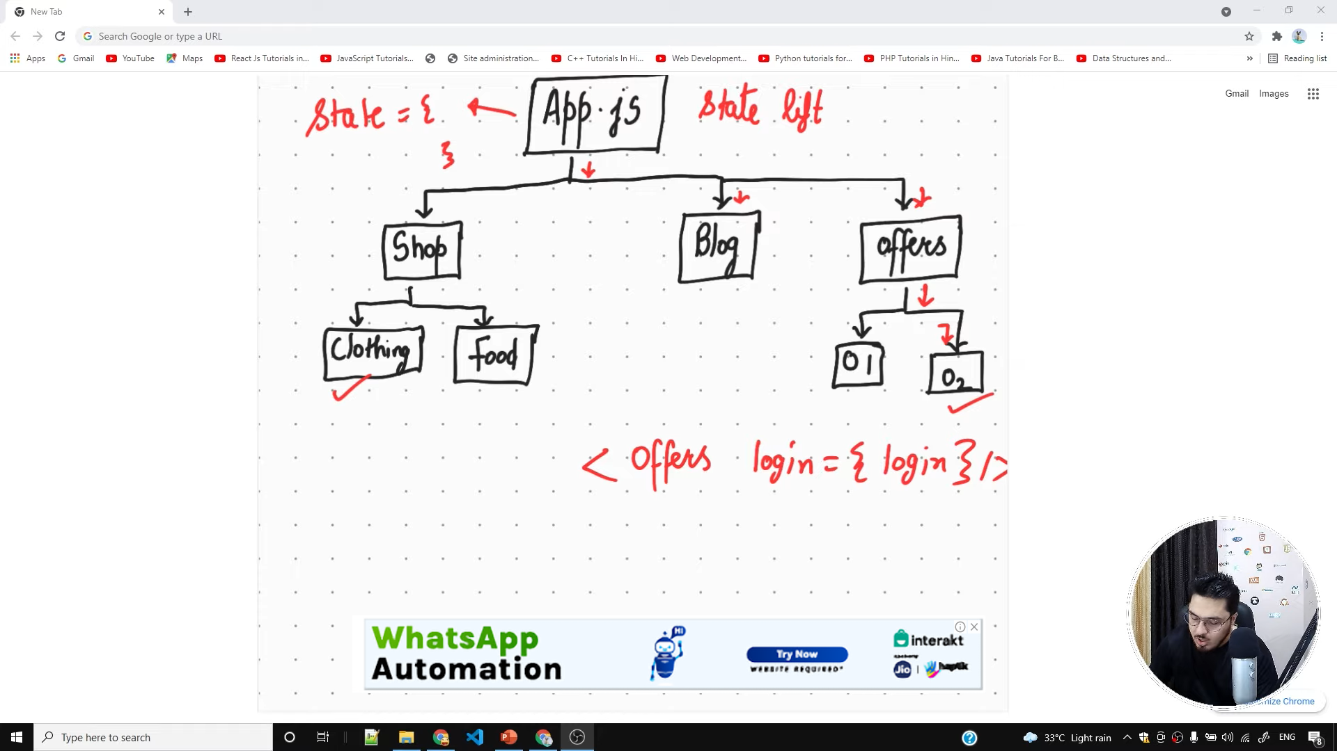

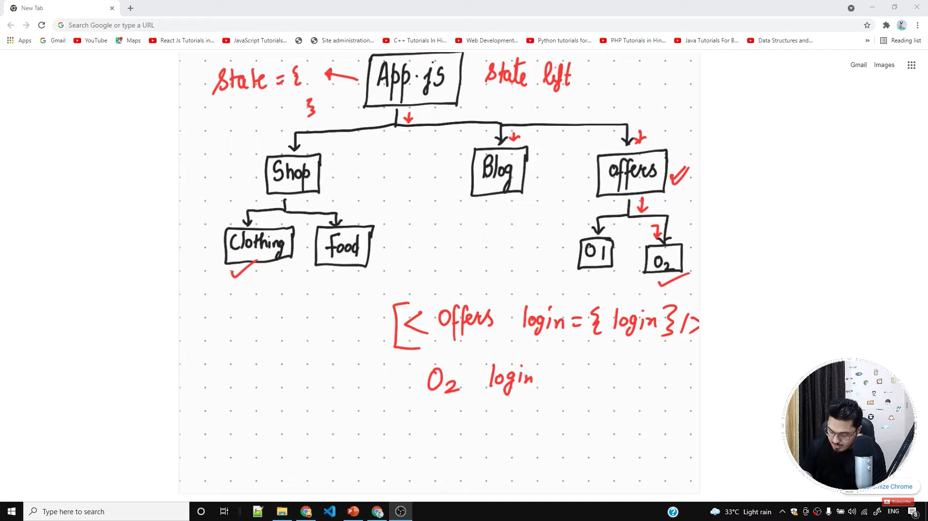

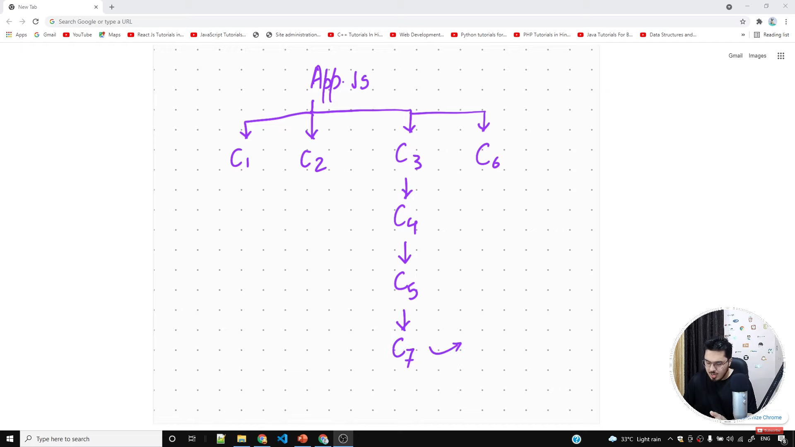

We Want to put a state color=green at C7 . We need to make it at App. Then pass it to other components

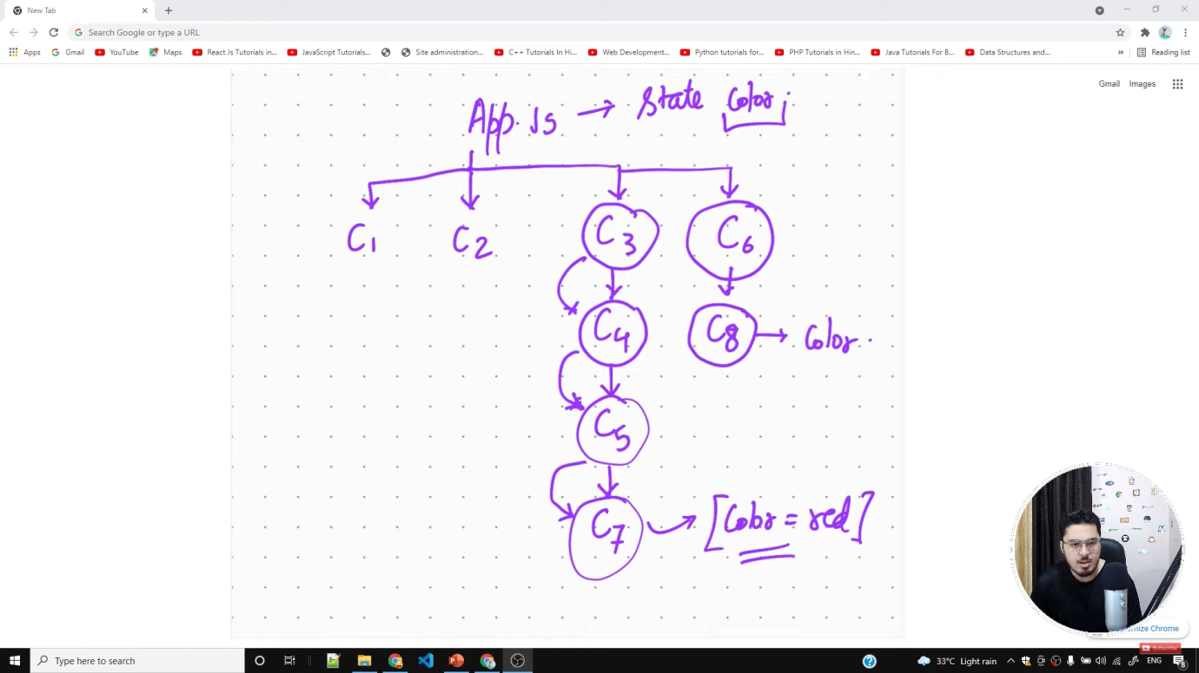State Management > Manage the state of variables

How do components interact from parent to child component > Using props

How do components interact from child to parent component > Using events

State Management

1. Context Api
2. Redux
3. Flux

Context API > To store the state

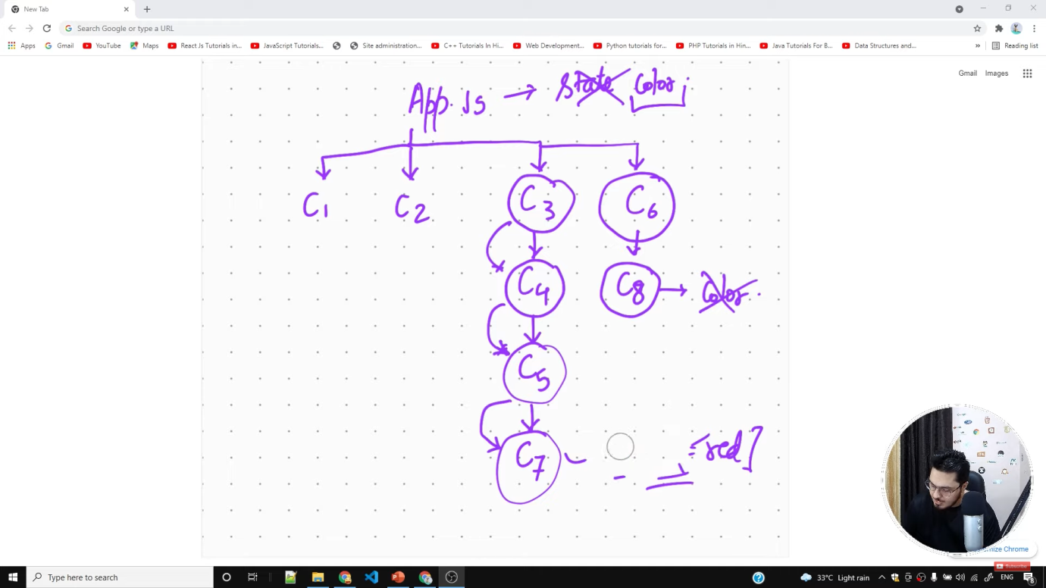  
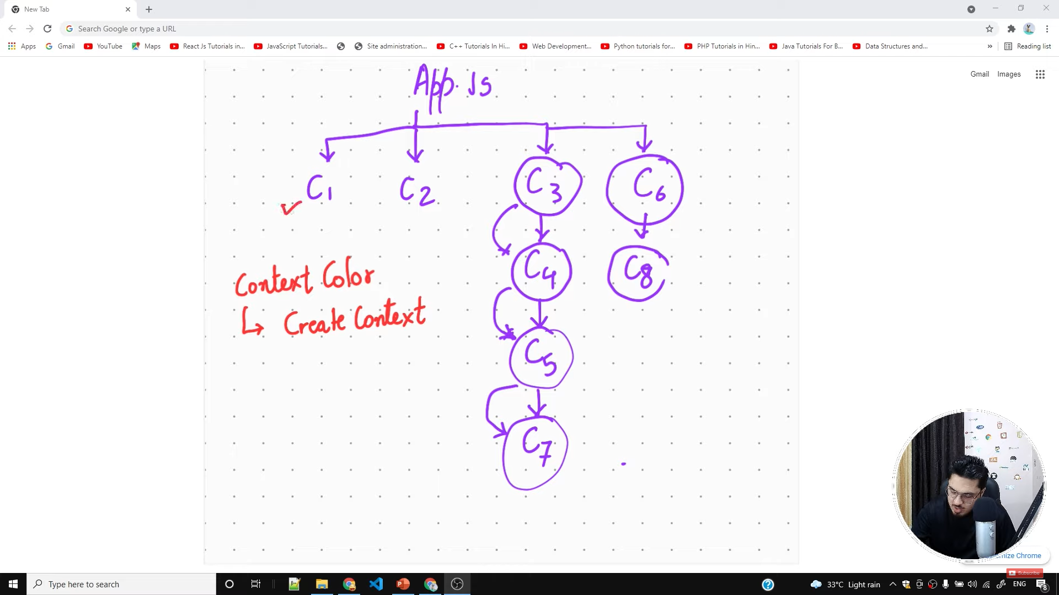

useContext Hook

